PATIENT INFORMATION
Date____________________
Patient_____________________________________

_________________________________________ Street
_________________________________________
City State Zip
Sex: □ M □ F Age_____ Birthdate__________________
□ Single □ Married □ Separated □ Divorced □ Widowed
Patient SS#_____________________________________

Occupation_________________________________________

Employer___________________________________________

Employer Address____________________________________

Employer Phone_____________________________________

Spouse’s Name______________________________________

Birthdate________________SS#________________________

Occupation_________________________________________

Spouse’s Employer___________________________________

Whom may we thank for referring you?
__________________________________________________

INSURANCE
Who is responsible for this account? ____________________________

Relationship to Patient_______________________________________

Insurance Co._______________________________________________

ID#________________________________ Group #_______________

Is patient covered by additional insurance? □ Yes □ No

Subscriber’s Name__________________________________________

Birthdate___________________SS#____________________________

Relationship to Patient_______________________________________

Insurance Co._______________________________________________

ID#__________________________________Group #______________

ASSIGNMENT AND RELEASE
I, the undersigned certify that I (or my dependent(s)) have insurance coverage with__________________________________________________and assign directly to
Foxworth Chiropractic all insurance benefits, if any, otherwise payable to me for services rendered. I understand that I am financially responsible for all charges whether or not paid by insurance. I hereby authorize the doctor to release all information necessary, to secure the payment of benefits. I authorize the use of this signature on all insurance submissions.
________________________________________________________________________
Responsible Party Signature
___________________________________________ ___________________________
Relationship Date

PHONE NUMBERS
Home_______________ Work_____________ Ext_________
Cell _________________________ Fax__________________
Email Address_______________________________________
*will not be shared with any other entity under penalty of Federal Law
IN CASE OF EMERGENCY, CONTACT
Name_____________________________________________
Home phone_______________ Relationship______________
Name of Nearest Relative______________________________
Phone or Nearest Relative______________________________
ACCIDENT INFORMATION
Is condition due to an accident? □ Yes □ No Date________________
Type of accident □ Auto □ Work □ Home □ Other
To whom have you made a report of your accident?
□ Auto Insurance □ Employer □ Worker Comp. □ Other
Supervisor/Adjuster ________________________________________________
Phone _______________________ State Accident Occurred in: ____________
Attorney Name (if applicable)________________________________________
Phone _____________________________________________________

PATIENT CONDITION
Reason for visit?__________________________________________________________________________________________________
When did your symptoms appear?____________________________________________________________________________________
If long-standing, when did THIS episode begin: _________________________________________________________________________
Is this condition getting progressively worse? □ Yes □ No □ Unknown
Mark an X on the picture where you continue to have pain, numbness, or tingling.
Rate the severity of your pain on a scale from 0 (least pain) to 10 (severe pain)___________
Type of pain: □ Sharp □ Dull □ Throbbing □ Numbness □ Aching □ Shooting
□ Burning □ Tingling □ Cramps □ Stiffness □ Swelling □ Other
How often do you have this pain?___________________________________________
Is it constant or does it come and go?________________________________________
Does it interfere with your □ Work □ Sleep □ Daily Routine □ Recreation
Activities or movements that are painful to perform □ Sitting □ Standing □ Walking □ Bending □ Lying Down

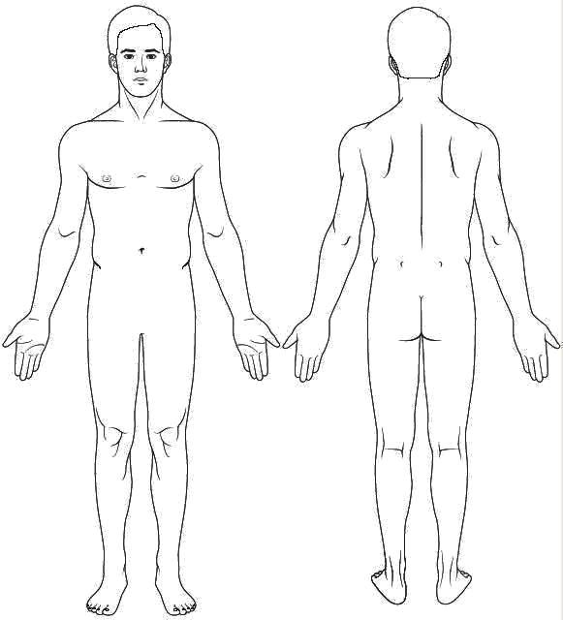

HEALTH HISTORY
What treatment have you already received for your condition? □ Medications □ Surgery □ Physical Therapy
□ Chiropractic Services □ None □ Other__________________________________________________________
Name of other doctor(s) who have treated you for your condition__________________________________________
Have you been told you may need surgery? __Yes __No
By Whom?:_____________________________________________________
What made you finally decide to seek treatment for this condition? (just won’t go away, pain, interference with work, family duties, recreation etc.):____________________________________________________________________________________
_______________________________________________________________________________________________________
What made you decide to see a Doctor of Chiropractic? (Referred by your physician, want to avoid side-effects of medicine, want to avoid surgery, want to treat naturally if possible, etc.):_____________________________________________________
_______________________________________________________________________________________________________

Family Doctor: __________________________________________________________________________________________
A report will be sent to your treating or referring physician(s) to keep them informed of your treatment and progress with your authorization.
Please initial: _____ Please provide a report to my physicians _____Please do NOT provide a report to my physicians

Date of Last: Physical Exam________________ Spinal X-Ray_________________ Blood Test_____________________
Spinal Exam__________________ Chest X-Ray__________________ Urine Test______________________
Dental X-Ray_________________ MRI, CT-Scan, Bone Scan____________________________________
Please circle any conditions below if you now have, or have had them in the past
AIDS/HIV |  | Emphysema |  | Miscarriage |  | Scarlet Fever
Alcoholism |  | Epilepsy |  | Mononucleosis |  | Stroke
Allergy Shots |  | Fractures |  | Multiple Sclerosis |  | Suicide Attempt
Anemia |  | Glaucoma |  | Mumps |  | Thyroid
Anorexia |  | Goiter |  | Osteoporosis |  | Problems
Appendicitis |  | Gonorrhea |  | Pacemaker |  | Tonsillitis
Arthritis |  | Gout |  | Parkinson's |  | Tuberculosis
Asthma |  | Heart Disease |  | Pinched Nerve |  | Tumors,
Bleeding |  | Hepatitis |  | Pneumonia |  | Growths
Disorders |  | Hernia |  | Polio |  | Thyphoid
Breast Lump |  | Herniated Disk |  | Prostate |  | Ulcers
Bronchitis |  | Herpes |  | Problems |  | Vaginal
Bulimia |  | High Blood Pressure |  | Prosthesis |  | Infections
Cancer |  | High Cholesterol |  | Psychiatric |  | Venereal
Cataracts |  | Kidney Disease |  | Care |  | Disease
Chemical |  | Liver Disease |  | Rheumatoid |  | Whooping
Dependency |  | Measles |  | Arthritis |  | Cough
Chicken Pox |  | Migraines |  | Rheumatic |  | Other:____________
Diabetes |  | Headaches |  | Fever |  | _________________
EXERCISE WORK ACTIVITY HABITS/OTHER
___ None ___ Sitting ___Smoking Packs/Day ________________________
___ Moderate ___ Standing ___Alcohol Drinks/Week ______________________
___ Daily ___ Light Labor ___Coffee/Caffine Cups/Day_________________________
___ Heavy ___ Heavy Labor ___ High Stress Level Reason __________________________

Are you pregnant? ___Yes ___No Due Date_________________________________________________________
Injuries/Surgeries you have had Description Date
Falls _______________________________________________________________________________ ________________
Head Injuries _________________________________________________________________________ ________________
Broken Bones/Dislocations ______________________________________________________________ ________________
Surgeries ____________________________________________________________________________ _________________
Medications Allergies Vitamins/Herbs/Minerals
______________________________ ______________________________ _____________________________
______________________________ ______________________________ _____________________________
______________________________ ______________________________ _____________________________

