AESTHETICS
WELCOME TO
GULFSHORE CONCIERGE MEDICINE
AND AESTHETICS
We are pleased to introduce Gulfshore Concierge Medicine Aesthetics. At the helm, we have Dr. Francesca Rudin, MD, Medical Director, who oversees the practice. She brings with her years of experience in healthcare as a licensed physician. Dr Rudin is both an adept Internist and well trained in the field of Aesthetics. As the previous Medical Director for her own aesthetics company, Beauty Thru Medicine, she has a dynamic background in the oversight and administration of aesthetic services. She offers a full array, from injections and fillers to advanced Laser treatments.
Dr. Rudin personally performs all services herself which ensures patients are receiving the highest quality care. Additionally, under this structure, each patient is presented with an individualized cosmetic treatment plan to achieve specific goals. This personalized plan will be designed just for you.
We are excited for you to experience our Private, Professional, and Exceptional services to help you feel your best and live confidently.

Downtown Office
Gulfshore Concierge Medicine
1350 Tamiami Trail N Suite 102
Naples, FL 34102
(239) 325-1020
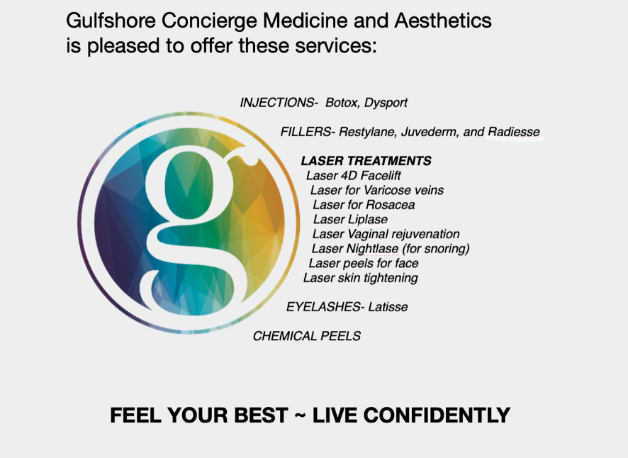
For more information please email downtown@gcmedicine.com
or call (239) 325-1020.

