HEALTH HISTORY QUESTIONNAIRE
All questions contained in this questionnaire are strictly confidential and will become part of your medical record.
Name (Last, First, M.I.): M F |  | DOB:
Marital status: Single Partnered Married Separated Divorced Widowed
Education level / background: | Occupation (pre-retirement):
Previous or referring doctor: | Date of last physical exam:
PERSONAL HEALTH HISTORY
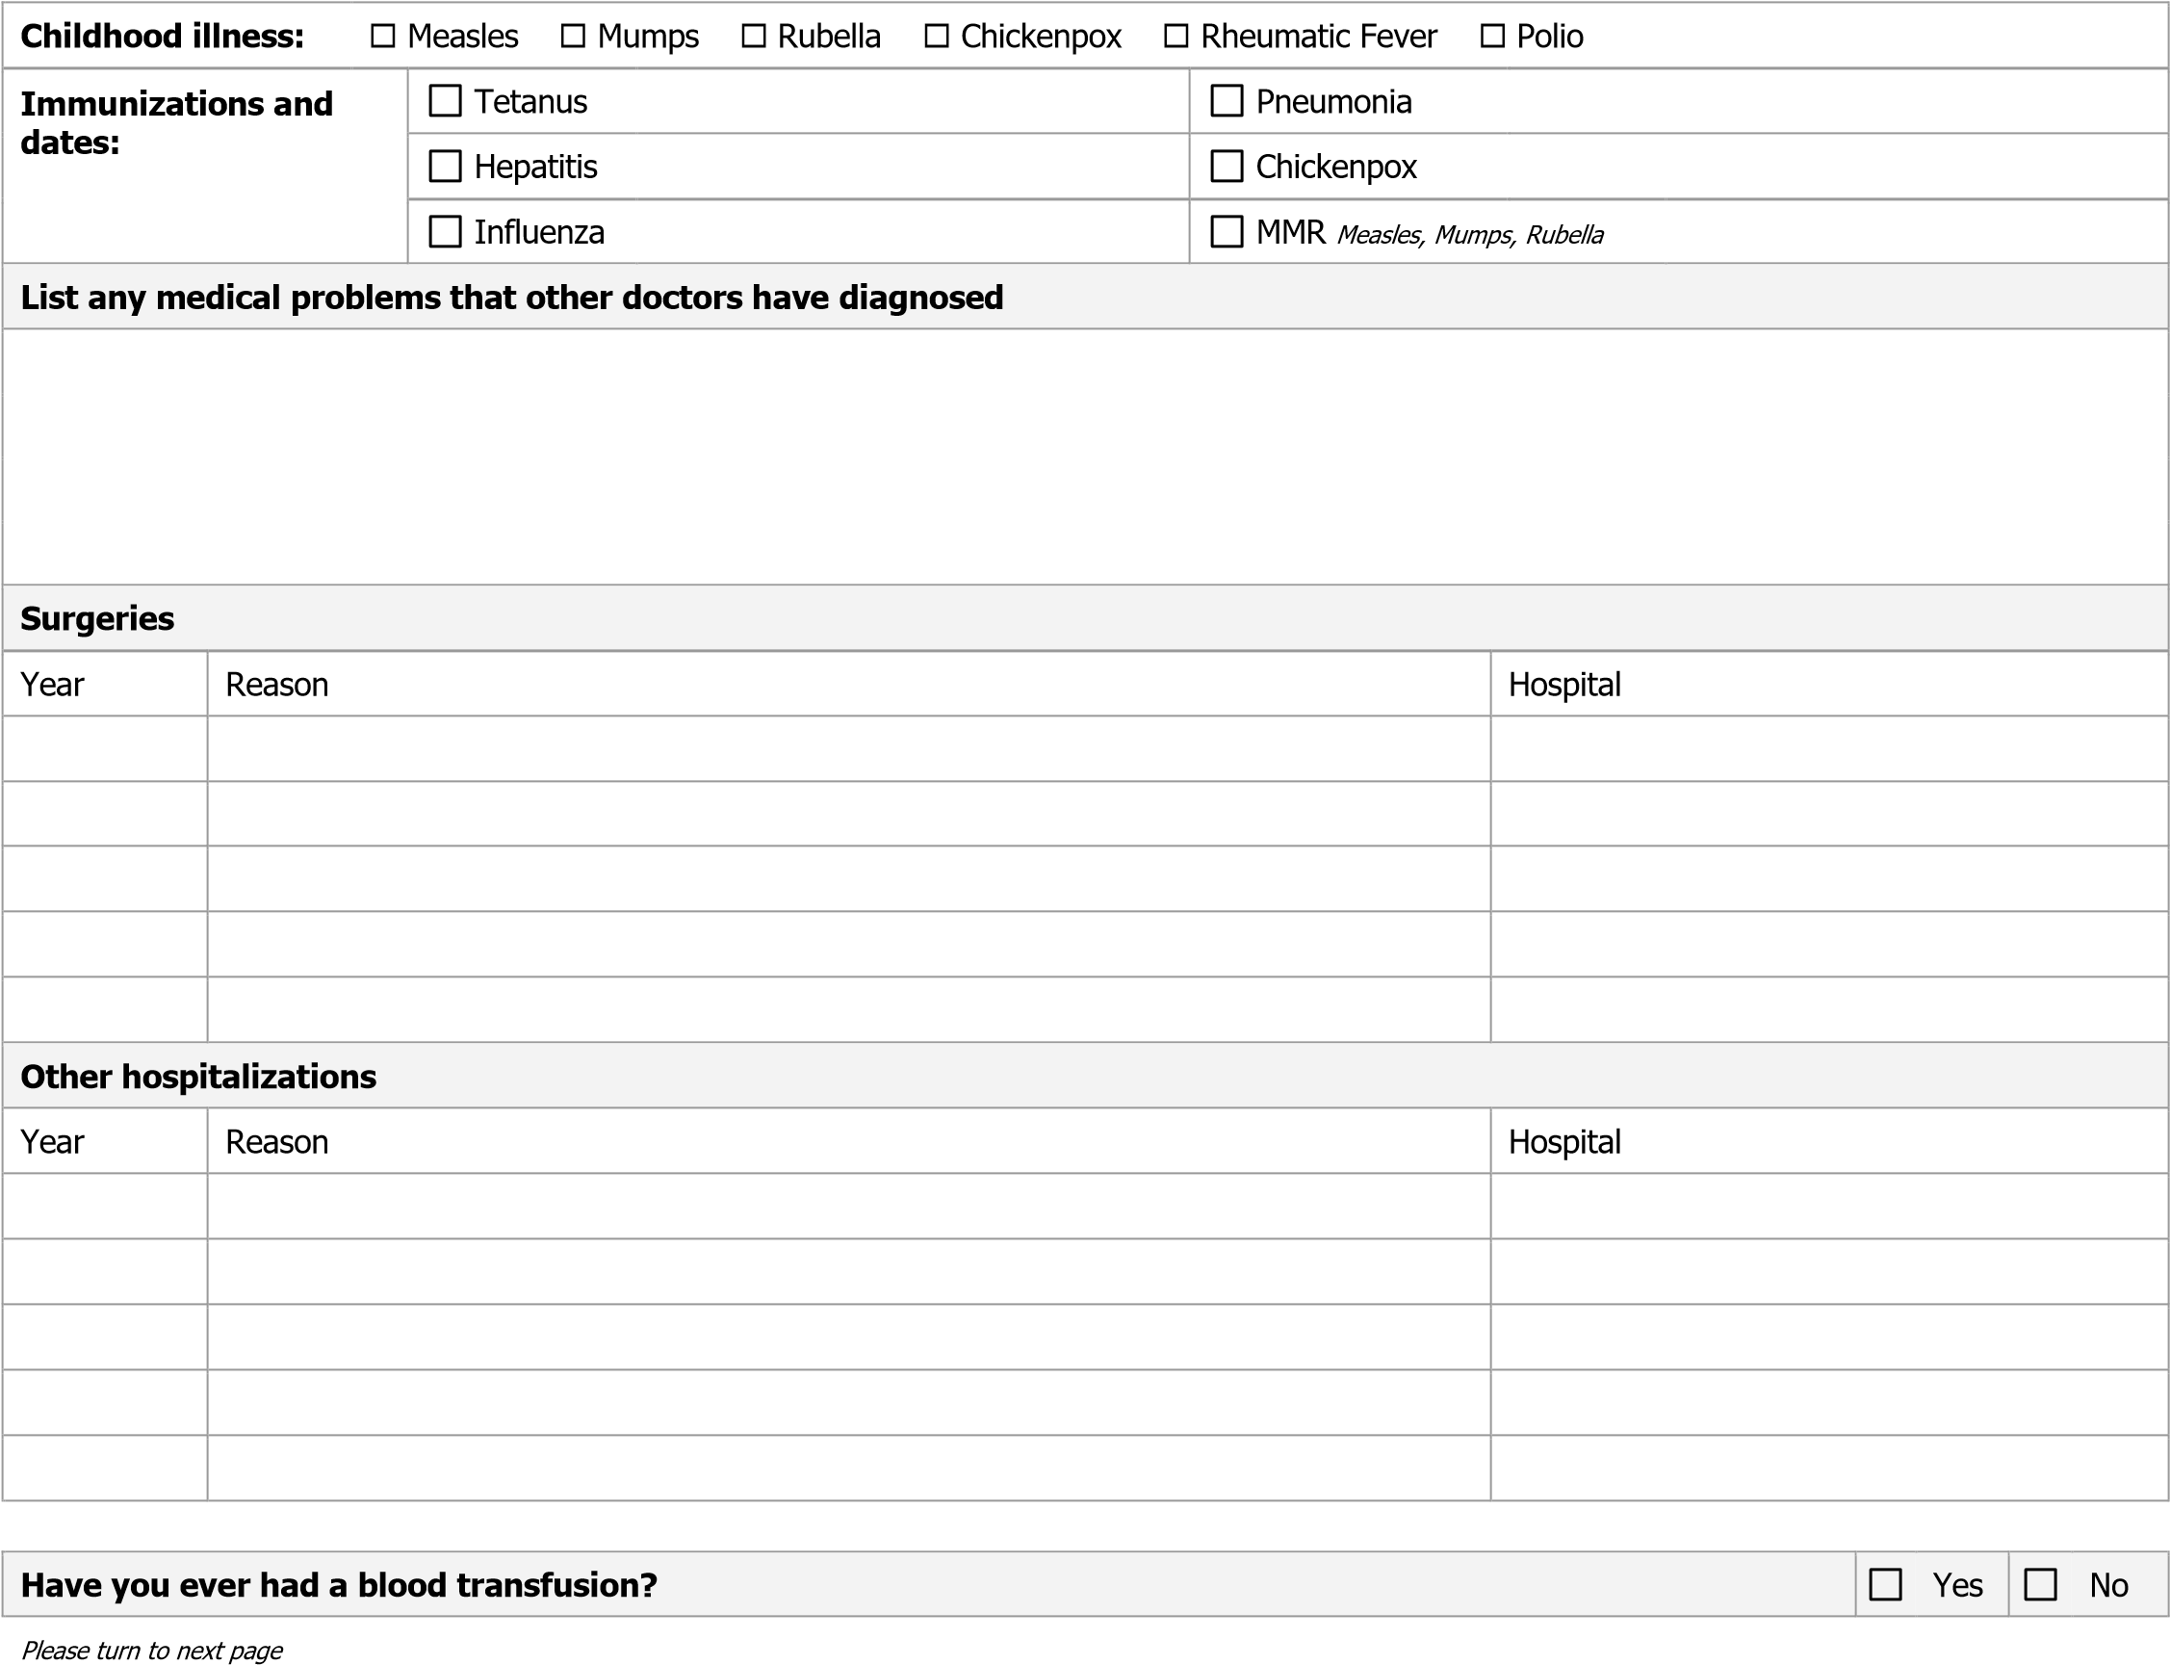

Prescription drugs and over-the-counter drugs, vitamins, and inhalers
Name the Drug | Strength | Frequency Taken
Allergies to medications
Name the Drug | Reaction You Had

HEALTH HABITS AND PERSONAL SAFETY
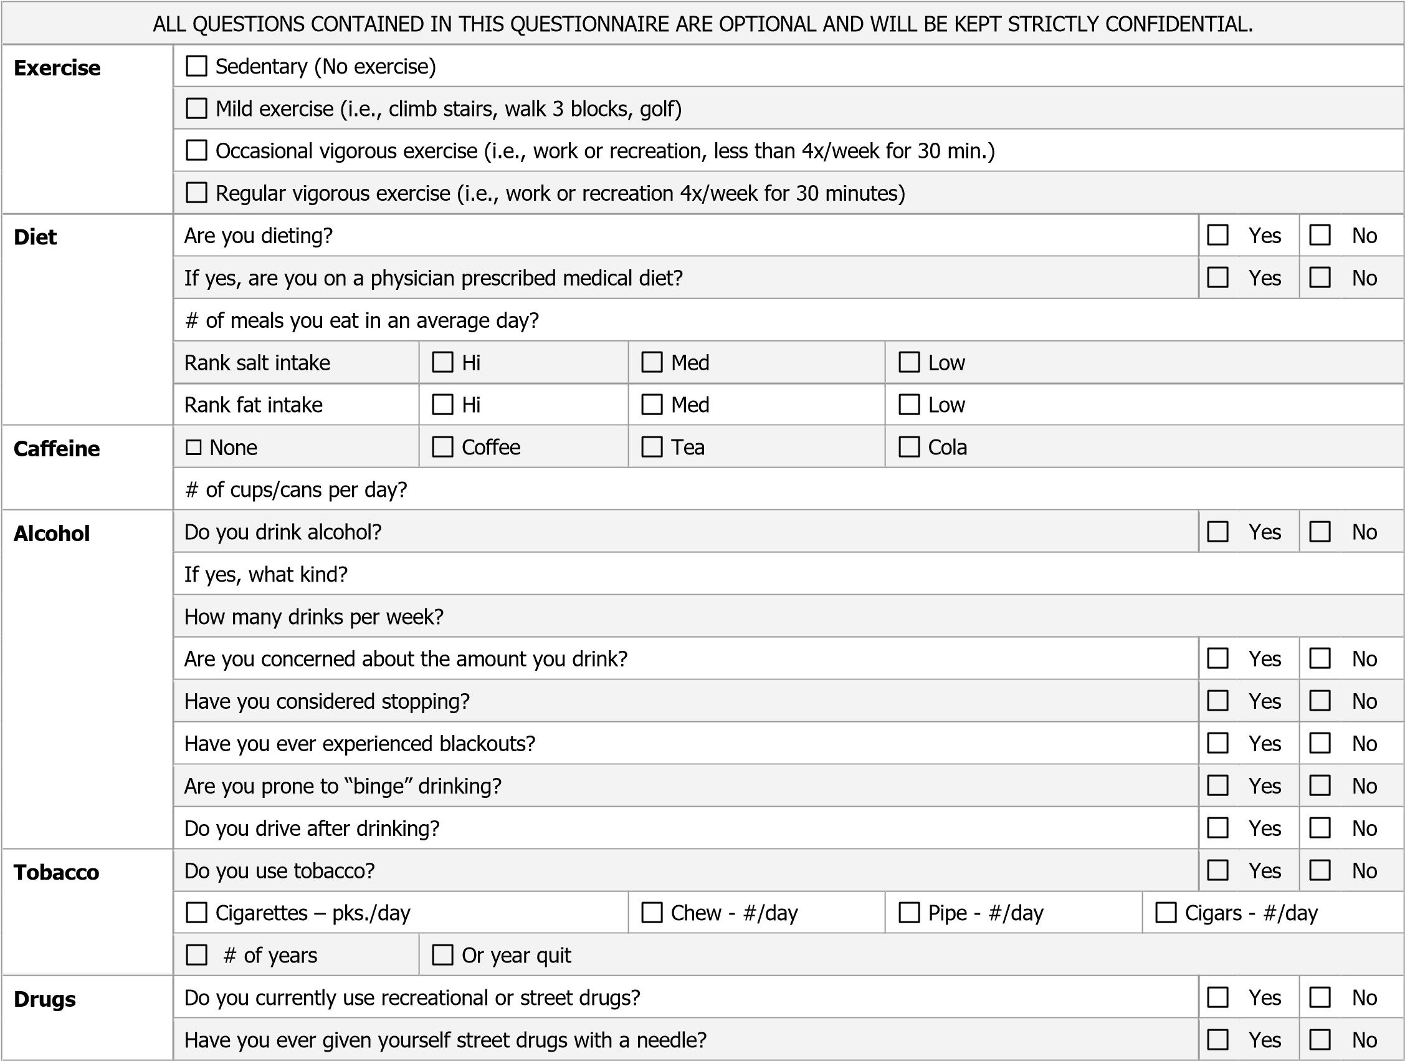
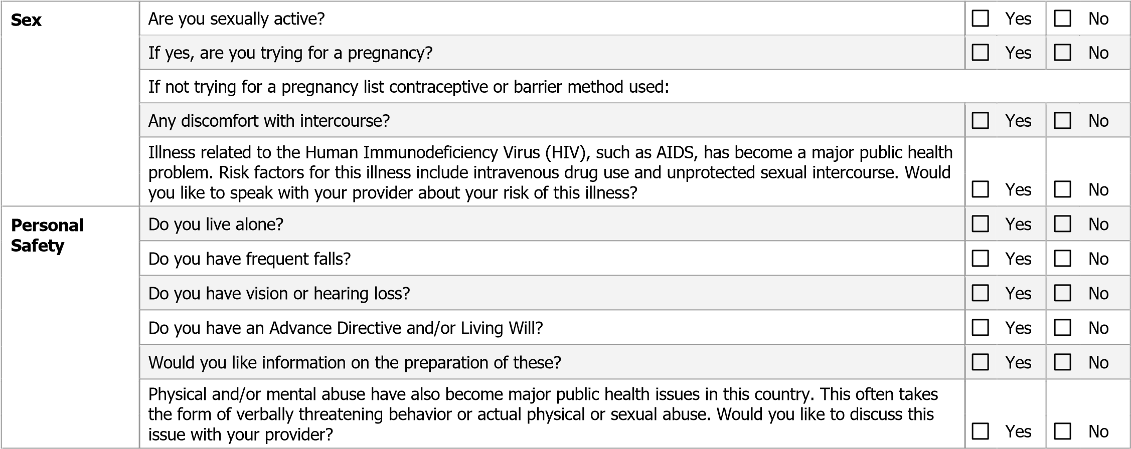

FAMILY HEALTH HISTORY
 | AGE |  |  | SIGNIFICANT HEALTH PROBLEMS |  | AGE |  |  | SIGNIFICANT HEALTH PROBLEMS
Father |  |  |  |  | Children |  |  | M  F
Mother |  |  |  |  |  |  |  | M  F
Sibling |  |  | M  F |  |  |  |  | M  F
 |  |  | M  F |  |  |  |  | M  F
 |  |  | M  F |  | Grandmother  Maternal
 |  |  | M  F |  | Grandfather  Maternal
 |  |  | M F |  | Grandmother  Paternal
 |  |  | M  F |  | Grandfather  Paternal
MENTAL HEALTH
Is stress a major problem for you? | Yes | No
Do you feel depressed? | Yes | No
Do you panic when stressed? | Yes | No
Do you have problems with eating or your appetite? | Yes | No
Do you cry frequently? | Yes | No
Have you ever attempted suicide? | Yes | No
Have you ever seriously thought about hurting yourself? | Yes | No
Do you have trouble sleeping? | Yes | No
Have you ever been to a counselor? | Yes | No
WOMEN ONLY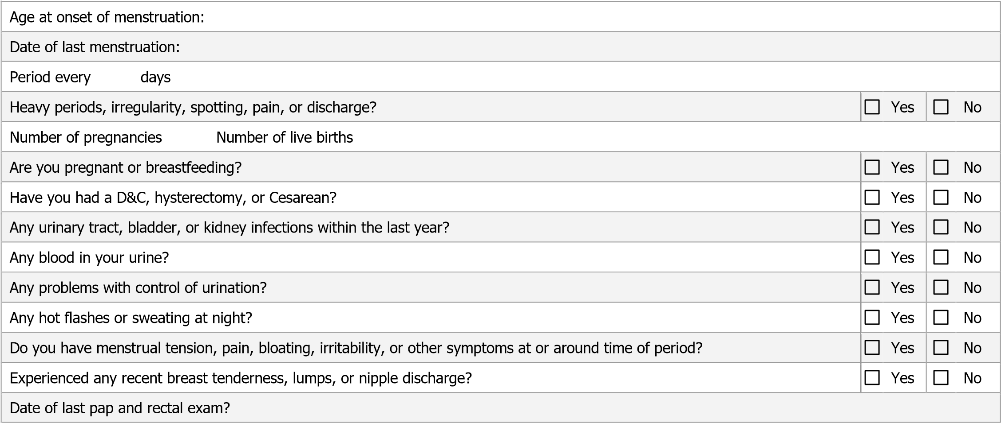MEN ONLY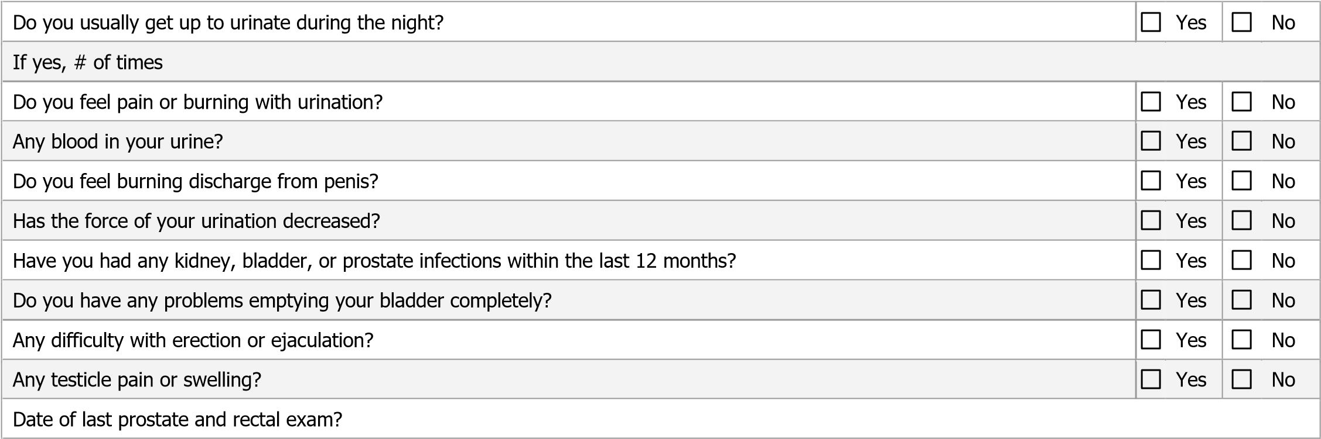OTHER PROBLEMS
Check if you have, or have had, any symptoms in the following areas to a significant degree and briefly explain.
Skin | Chest/Heart | Recent changes in:
Head/Neck | Back | Weight
Ears | Intestinal | Energy level
Nose | Bladder | Ability to sleep
Throat | Bowel | Other pain/discomfort:
Lungs | Circulation

