NEW PATIENT FORM

Date:_____-_____- _____

Name:___________________________________________ DOB:___-___-___ Age____ Ht _____ Wt _____
Referred by a physician?___Yes___No Name:___________________________________________________
Primary care physician if different from above. Name__________________________________________________
1. REASON FOR VISIT(LOCATION):_________________________Describe Pain (sharp , dull , ache)?______________
2. WHEN did your problem begin?_____________________________Constant, or Come and Go? _____________
3. HOW did your problem begin?___________________________________________________________________
4. What are the symptoms (pain, locking, clicking , numbness)? ________________________________________________________
5. What makes the problem Worse? _______________________________Better?_____________________________
6. Have you had any diagnostic tests for this problem? (Please check all that apply)
□ X-rays □ Arthrogram (Dye injection) □ Electromyogram (EMG)
□ MRI or CT □ Injections (Cortisone) □ Nerve Conduction Study (NCS)
Dates:_________Place:___________ Have they been delivered here? ⁭Yes ⁭No Do you have them? ⁭Yes ⁭No
9. Were you seen in the Emergency Room for this problem? ⁭Yes Date______ No ⁭
10. Have you seen an Orthopedist for this problem?________________________________________________
11. What treatment have you had for this problem?______________________________________________________
12. PAIN SCALE ( least) 1 2 3 4 5 6 7 8 9 10 (greatest)
13. Are you RIGHT ⁯ or LEFT ⁯ Handed

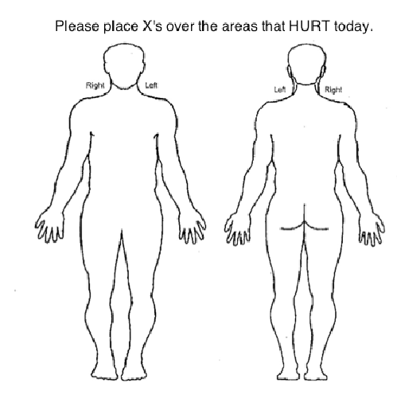
For office use only:

F/S? -

14. PAST MEDICAL HISTORY:
⁭ Diabetes ⁭ Stomach Ulcers/Reflux
⁭ Asthma/Emphysema/COPD ⁭ Stroke
⁭ High Blood Pressure ⁭ Kidney disease/failure(specify)
⁭ Heart Problems:
⁭ Easy Bleeding or Bruising Contagious conditions: ⁭ HIV ⁭ Hepatitis ⁭ TB/Other (specify)
⁭ Cancer (What type!) Other:________________

15 .ALLERGIES: Do you have allergies to: Specify Allergy and Reaction (i.e. itching, rash, hives, difficulty breathing)
Drugs ⁭ Yes ⁭ No What : _______________________
Tape? ⁭ Yes ⁭ No What : _______________________
Latex? ⁭ Yes ⁭ No What : _______________________
Food? ⁭ Yes ⁭ No What : _______________________
Lidocaine or Steroids ⁭ Yes ⁭ No What : _______________________

16. MEDICATIONS: Do you take any medications? Please list all medications and their doses.

17. FAMILY HISTORY: Does anyone in your family have a history of any medical problems? (Please check all that apply)
⁭ Arthritis ⁭Blood Clots ⁭ Problems with Anesthesia
⁭ Cancer ⁭ Osteoporosis ⁭ Heart Disease
⁭ Diabetes _____Other______________________
18. SOCIAL HISTORY:
What is your occupation? _____________________________ Full Time ⁯ Retired ⁭ Disabled ⁭
Do you smoke? ⁭Yes ⁭ No How much? ______________ Did you smoke? ⁭Yes ⁭ No Quit when?_________
Do you drink alcohol? ⁭ Yes ⁭ No ⁭ Rarely ⁭ Socially ⁭ Daily How many drinks per day? __________________
Have you ever had any addiction to drugs or medications? ⁭ Yes ⁭ No Which?___________________________________
Are you ⁭ Married ⁭ Single ⁭ Committed ⁭ Widowed ⁭ Divorced/Separated Do you live alone? ⁭Yes ⁭ No
Do you exercise? ⁭ Daily ⁭ Weekly ⁭ Monthly ⁭ Rarely ⁭ Never
19. REVIEW OF SYSTEMS :
DO YOU HAVE PROBLEMS WITH THE FOLLOWING:
General ⁭ fevers/chills ⁭ sweats ⁭ tiredness/fatigue ⁭ weight loss ⁭ None
Eyes ⁭ blurring ⁭ double vision ⁭ vision loss ⁭eye pain ⁭ photophobia ⁭ None
ENT ⁭ ear pain/discharge ⁭ hearing problems/ringing ⁭ nosebleeds ⁭hoarseness ⁭difficulty swallowing ⁭ None
CV ⁭ chest pain ⁭ irregular heart beat ⁭ passing out ⁭ orthopnea ⁭ swelling in legs ⁭ None
Resp ⁭shortness of breath ⁭wheezing ⁭cough ⁭ cough up blood ⁭ None
GI ⁭nausea/vomiting ⁭ diarrhea ⁭ constipation ⁭ abdominal pain ⁭blood in stool ⁭ black bowel movements ⁭ None
GU ⁭burning ⁭ loss of urine ⁭ difficulty voiding ⁭ infections ⁭ blood in urine ⁭ sexual dysfunction ⁭ None
MSK – See HPI
Skin ⁭rash ⁭itching ⁭dryness ⁭strange lesions ⁭ None
Neurologic ⁭ weakness ⁭seizures ⁭ dizziness ⁭balance problems ⁭memory problems ⁭ None
Psychiatric ⁭depression ⁭anxiety ⁭sleep disturbance ⁭hallucinations ⁭suicidal thoughts ⁭ None
Endocrine ⁭cold or heat intolerance ⁭thirsty all the time ⁭peeing a lot ⁭large weight gain/loss ⁭ None
Heme/Lymph ⁭easy bruising ⁭anemia ⁭enlarged glands ⁭bleeding ⁭ None
Allrgc/ Immun ⁭Itching ⁭frequent colds/infections ⁭HIV exposure ⁭ None

