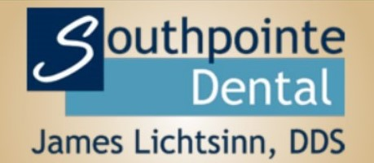
DENTAL QUESTIONNAIRE

Name: _____________________________________ Date: _____________________

Answering the following questions to the best of your ability will allow us to render optimum care
specific to your individual dental needs.

What is your immediate dental concern today? (check-up, pain, etc...)___________________________
__________________________________________________________________________________

When was your last dental appointment? _______________________________________________

~What was done at that appointment? ______________________________________________

When was your last dental cleaning? ______________________ Last dental x-rays_____________

Have you ever taken an antibiotic prior to dental treatment? Yes No

Are you experiencing or have you ever experienced:
YES NO
YES NO
YES NO
YES NO
YES NO
YES NO
YES NO
YES NO
YES NO
YES NO
YES NO
YES NO
YES NO
YES NO
YES NO
YES NO
Bleeding Gums……………………... Gum (periodontal) Treatment……….….
Sores or Lumps in Mouth ……….… Bad Breath/Unpleasant Taste…….……
Extraction Complication…………… Extraction of Wisdom Teeth……….……
Difficulty Chewing…………………... Sensitive Teeth ……………………..……
Loose Teeth ………………………… Chipped/Broken Teeth…………….……..
Clenching or Grinding of Teeth……. Clicking or Locking of the Jaw ……….…
Jaw Pain……………………………… Headaches or Migraines…..………..……
Problems with Novocain……………. Braces (orthodontia)……………….……..

How would you rate your smile?*
It’s awesome! I love it! I’m happy with my smile but would consider some minor changes
It’s OK (mildly dissatisfied) I’m unhappy with the appearance of my teeth
I’m embarrassed to smile or show my teeth

What would you like to change about your teeth? ________________________________________

Are you interested in whiter teeth? ___________________________________________________

Please describe any problems you’ve had with past dental experiences if applicable.
__________________________________________________________________________________

Any other questions or comments about your dental care that you would like Dr Lichtsinn to address? __________________________________________________________________________________
__________________________________________________________________________________

